1. Sensation and Perception
   1. Sensation
      1. Overview of sensory information processing
         1. Stimulus energy, transduction, iconic/echoic storage, selection for further processing
         2. Transduction
            1. Raw energy is converted into neuro signals that are then sent to the brain
            2. The process of taking that stimulus energy and translating them into electrical activity
         3. Iconic/Echoic Storage
            1. Very brief memory systems that hold onto everything that hits your senses
            2. Some information, but not all, is selected for further processing
            3. There’s a lot of information that’s available to you that hit your senses that you’re not consciously aware of.
      2. Sensation is a process of picking up that information
   2. Perception
      1. The information you first pick up (Sensation) is meaningless
      2. The process of organizing, sorting through, and arranging that information into a meaningful form
      3. Interpreting sensation
      4. Young / Old Woman Example
         1. The sensation is the same, the perception is different.
      5. Perceptual Organizing
         1. Gestalt Psychology
            1. The whole is greater than the sum of its parts

Figure and ground

Look at image online

* + - * 1. Human beings have a natural tendency to see meaningful patterns, whole objects, we don’t see bits and pieces.
        2. You see a desk, not a bunch of nails and wood
        3. We have the ability to focus on one figure to the exclusion of everything behind it
    1. Perceptual Constancies
       1. Constancy
          1. Allows perception to remain stable, even though the image on our retina is changing
          2. Once we form a stable impression of something, we can recognize it from any angle or impression
       2. Size Constancy
       3. Shape Constancy
          1. No matter where you are in the room, the image on your retina is very different, you can still recognize it as a folder
          2. Very simple skill but important
    2. Perceiving distance and depth
       1. Binocular depth cues
          1. Good for closer objects
          2. Retina disparity

Refers to the fact that because our eyes are set about 2 ½ inches apart each eye actually has a slightly different view of the world

It’s the combination of both of those images that helps you perceive depth

Hole in hand example

* + - * 1. Convergence

The movement of your eye muscles, tells you how close an object is

* + - 1. Monocular depth cues
         1. Good for farther away objects
         2. This Is what artists use to make things look more life-like
         3. Texture gradients

As the distance increases, the texture will become finer and finer until it can’t be distinguished

Objects close to you appear to have a rougher or more detailed texture, those farther are much hazier and smoother

* + - * 1. Linear perspective

Two parallel lines that extend into the distance appear to come together at some point on the horizon

* + 1. Origins of depth perception
       1. Depth perception as inborn
          1. Visual cliff experiments suggest some innate aspects of depth perceptions
          2. Visual Cliff

Using six month old on checkerboard glass table

* + - 1. Perceptual experience
         1. Real world experience over time is important to development of depth perception
         2. Virgil was an individual who had experienced very bad cataracts, as an adult surgeons surgically removed his cataracts and restored his vision. He was 30ish and for the first time he was able to see, he didn’t understand anything. He’d jump over shadows. He’d trip on stairs, because all he saw was parallel lines with lines drawn on them. When he got his cataracts back, he preferred to be blind.
         3. We have to have real world experience to practice our depth
    1. Perceptual Set
       1. Expectation and prior experiences can influence perceptions.
       2. If told to see an old woman, you’d be much more likely to view an old woman
    2. Visual Illusions
       1. Misleading cues that create inaccurate or impossible perceptions
          1. Over application of basic rules that are normally there to help you
       2. Muller-lyer
          1. 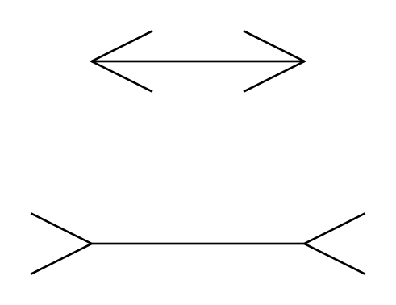
       3. Ponzo Illusions
          1. 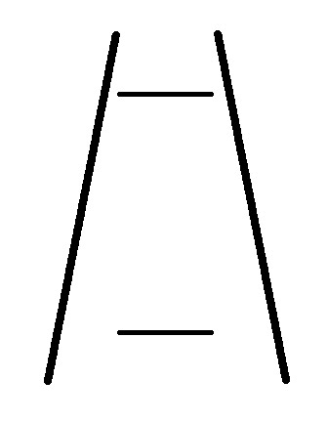
       4. Velocity-Size Illusion
          1. A large train appears to move much slower than a sports car even if going the same speed
       5. Rotating objects when not rotating
          1. When you see that object normally it’s rotating, when you see it still in an image you see it rotating
       6. Purple dot with one removing
          1. You will eventually not see any dots anymore, or green dots that never actually exist